1. For every year, the average temperature and rainfall of each month in city ‘A’ are shown in the table below.
2. Please draw curves for the changes of the rainfall and temperature along the changing of the months. Please label the titles of the coordinate axes, the location of the given points and the corresponding values.
3. Display the two curves in one figure window.

(There are examples below Table1.)

Table1 Temperature-rainfall values

|  |  |  |
| --- | --- | --- |
| month | Temperature(℃) | Rainfall(mm) |
| 1 | 0.2 | 4.6 |
| 2 | 2.3 | 3.6 |
| 3 | 8.7 | 2.1 |
| 4 | 18.5 | 2.9 |
| 5 | 24.6 | 3.0 |
| 6 | 32.1 | 2.7 |
| 7 | 36.8 | 2.2 |
| 8 | 37.1 | 2.5 |
| 9 | 28.3 | 4.3 |
| 10 | 17.8 | 3.4 |
| 11 | 6.4 | 2.1 |
| 12 | -3.2 | 3.7 |

Example:

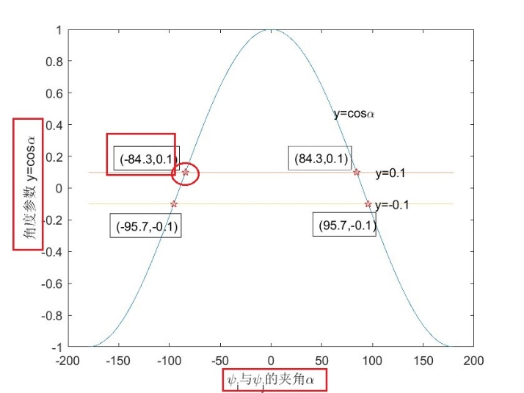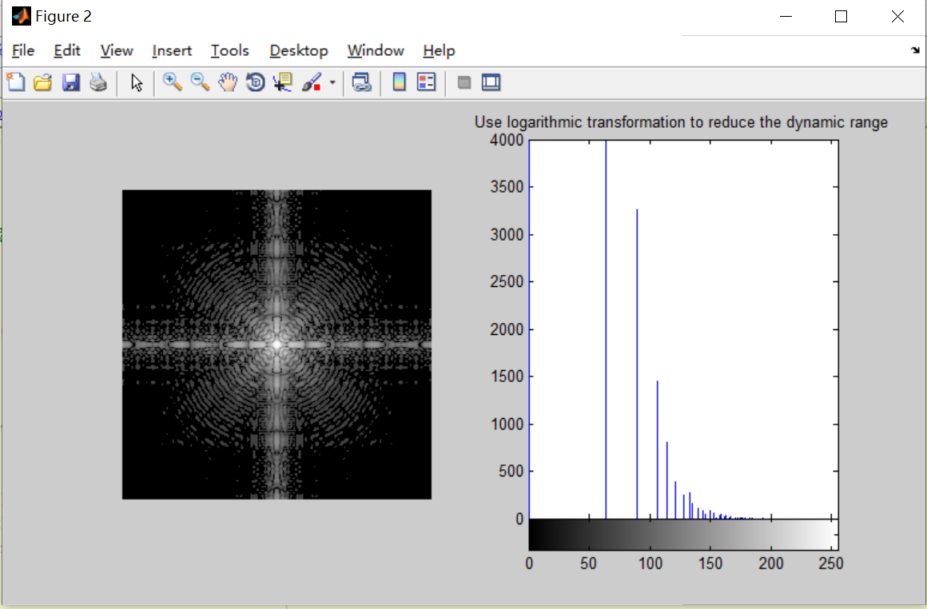

**the location and the corresponding values**

**the titles of the axes**

1. Find the number in [2,999] that satisfies both of the following conditions and output the results values as a vector.
2. The sum of the digits of this number is odd.

For example: sum of the digits of 535 is 5+3+5=13, is an odd number.

1. It is a prime number.

A prime number is a natural number greater than 1, and can be divisible only by itself and 1.